**Tutorial 32: Two-way Data Binding – Deleting Skills**

In this tutorial we will be attaching a click event to each skill that is outputted so that when a user clicks on one of those skills, we delete it from the array.

Make sure **Tutorial 31** is complete to be able to move on to this tutorial or clone the [vue3-firebase-course](https://github.com/younggrasshopperza/vue3-firebase-course) repository and go to branch called **Tutorial-31** and navigate to the web-form folder.

**Step 1:** In the **Signup.vue** file, where the skills is being outputted, create a span tag that outputs the skills, inside the span add a click event called deleteSkill, that passes an argument called skill.

Look at the example below (**Line 21**):

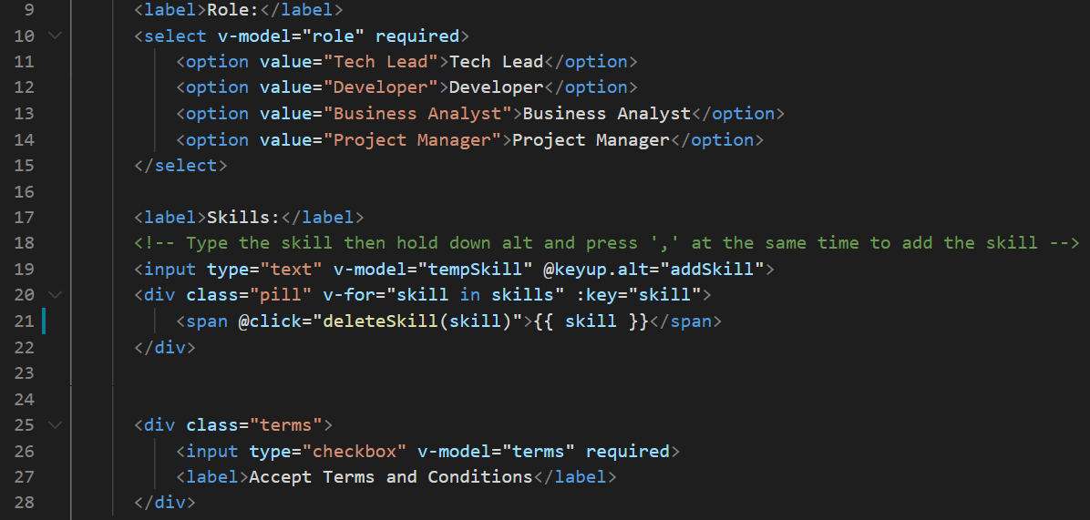

**Step 2:** In the **Signup.vue** file, create the deleteSkill in the methods property, that filters through the array and returns all the values in the array where the skill selected is not equal to the skills in the array.

Look at the example below (**Between Line 60 and line 65**):

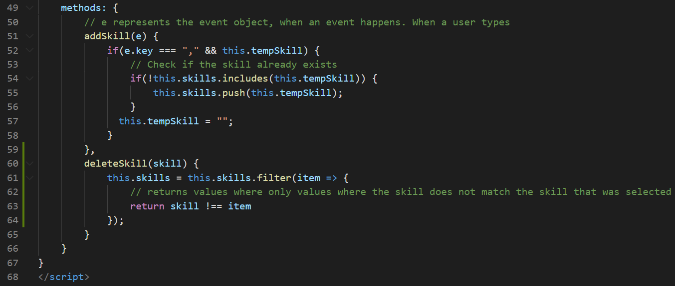

Add skills, then hover over and click on a skill.

**Output:**

Added skills

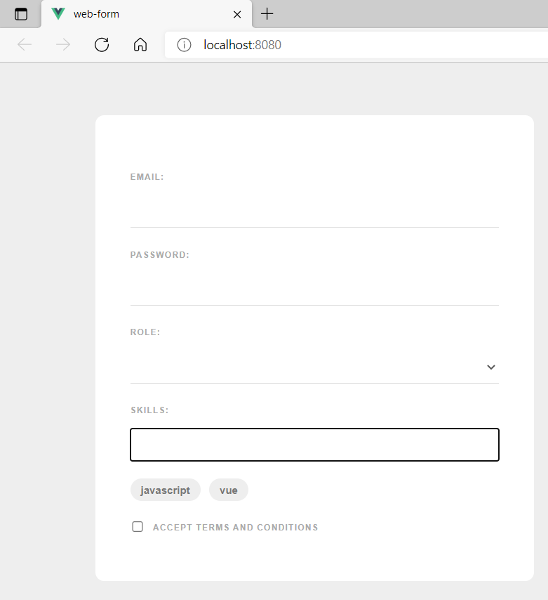

**Output:**

Deleted skill

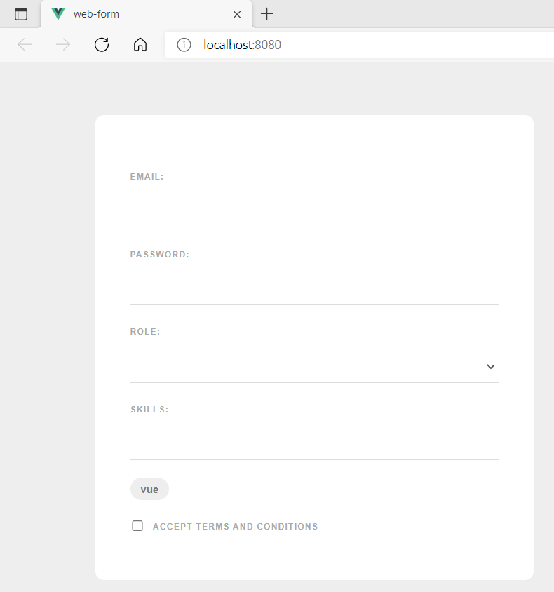

**You can view the code snippets from the** [**vue3-firebase-course**](https://github.com/younggrasshopperza/vue3-firebase-course) **repository under the Tutorial-32 branch**.